**Source Analysis – Gaius Marius**

Using the **TWO (2)** sources provided in the Source Booklet, answer the following questions:

1. *Tick* **one (1)** of the following in (a) and (b) to best describe **Source 1.**  (3 marks)
   * + 1. ancient source ☐
       2. modern source ☐

***AND***

* + - 1. written source ☐
      2. archaeological source ☐
      3. map/diagram ☐
      4. reconstruction ☐

State a reason to support your response:

_____________________________________________________________________________________________________________________________________________________________________________________________

|  |  |
| --- | --- |
| **Description** | **Marks** |
| Correctly identifies the descriptions of Source 1  (Ancient & Written Source) | 1 - 2 |
| Accurately outlines reason/s for selection of type/s of source | 1 |
| No/incorrect attempt at Question 1 | 0 |
| **Total:** | **3** |

1. *Outline* **FOUR (4) pieces of information** that are provided by **Source 1**.        (4 marks)

_____________________________________________________________________________________________________________________________________________________________________________________________________________________________________________________________________________________________________________________________________________________________________________________________________________________________________________________________________________________________________________________________________________________________________________________________________________________________________________________________________________________________________________________________________________________________________________________________________________________________________________________________________________________________________________________________________________________________________________________________________________________________________________________________________________________

|  |  |
| --- | --- |
| **Description** | **Marks** |
| Correctly outlines four pieces of information that are provided by Source 1 | 4 |
| Correctly outlines three pieces of information that are provided by Source 1 | 3 |
| Correctly outlines two pieces of information that are provided by Source 1 | 2 |
| Correctly outlines one pieces of information that are provided by Source 1 | 1 |
| No/incorrect attempt at Question 2 | 0 |
| **Total:** | **4** |

1. *Identify* and *discuss* the **historical context** of **Source 1**. You should consider the following where appropriate:
   * + - * relevant event/s
         * significant person/people
         * key idea/s depicted in the source. (4 marks)

____________________________________________________________________________________________________________________________________________________________________________________________________________________________________________________________________________________________________________________________________________________________________________________________________________________________________________________________________________________________________________________________________________________________________________________________________________________________________________________________________________________________________________________________________________________________________________________________________________________________________________________________________________________________________________________________________________________________________________________________________________________________________________________________________________________________________________________________________________________________________________________

|  |  |
| --- | --- |
| **Description** | **Marks** |
| Accurately identifies and discusses the historical context of Source 1, demonstrating a sound historical knowledge of the period.  The answer includes discussion of:   * relevant event/s and/or * significant person/people and/or * key idea/s | 4 |
| Identifies and briefly discusses the historical context of Source 1, demonstrating some historical knowledge of the period, but with omissions.  The answer includes discussion of:   * relevant event/s and/or * significant person/people and/or * key idea/s | 3 |
| Identifies and provides a simple description the historical context of Source 1, demonstrating a limited historical knowledge of the period.  The answer includes discussion of:   * relevant event/s and/or * significant person/people and/or * key idea/s | 2 |
| The answer demonstrates little historical knowledge of the period, with very simple description of:   * One (or two) of the criteria mentioned above, or * The answer is factually inaccurate, or * The answer simply describes the source | 1 |
| No/incorrect attempt at Question 3 | 0 |
| **Total:** | **4** |

1. *Identify* and *explain* the **message/s** of Source 2. Provide evidence in your response. (4 marks)

____________________________________________________________________________________________________________________________________________________________________________________________________________________________________________________________________________________________________________________________________________________________________________________________________________________________________________________________________________________________________________________________________________________________________________________________________________________________________________________________________________________________________________________________________________________________________________________________________________________________________________________________________________________________________________________________________________________________________________________________________________________________________________________________________________________________________________________________________________________________________________________

|  |  |
| --- | --- |
| **Description** | **Marks** |
| Accurately identifies and clearly explains the message/s of Source 2. Provides clear evidence to support the answer. | 4 |
| Identifies and briefly explains the message/s of Source 2. Provides limited evidence to support the answer. | 3 |
| Identifies and describes a message of Source 2, with little explanation and/or evidence provided. | 2 |
| The answer reflects little understanding of Source 2, with a simple recount of the contents of the source. | 1 |
| No/incorrect attempt at Question 4 | 0 |
| **Total:** | **4** |

1. *Outline* and *briefly explain* the major changes occurring in the society, which are depicted in **Source 1** and **Source 2**. Provide evidence in your response. **(6 marks)**

_______________________________________________________________________________________________________________________________________________________________________________________________________________________________________________________________________________________________________________________________________________________________________________________________________________________________________________________________________________________________________________________________________________________________________________________________________________________________________________________________________________________________________________________________________________________________________________________________________________________________________________________________________________________________________________________________________________________________________________________________________________________________________________________________________________________________________________________________________________________________________________________________________________________________________________________________________________________________________________________________________________________________________________________________________________________________________________________________________________________________________________________________________________________________________________________________________________________________________________________________________________

|  |  |
| --- | --- |
| **Description** | **Marks** |
| Accurately outlines and clearly explains one major change depicted in Source 1 and one major change depicted in Source 2.  Supports answer with evidence from each source | 6 |
| Accurately outlines and explains one major change depicted in Source 1 and one major change depicted in Source 2.  Attempts to support answer with limited evidence from the sources | 5 |
| Accurately outlines and clearly explains one major change depicted in one of the sources.  Supports answer with evidence from the source AND  Outlines one major change depicted in the other source.  Provides some explanation of the change or limited evidence from the source | 4 |
| Outlines one major change depicted in one of the sources.  Provides some explanation of the change and some evidence from the source AND  Outlines one major change depicted in the other source with inaccuracies in the explanation or little supporting evidence for the other source | 3 |
| Identifies one major change depicted in Source 1 and one major change in Source 2 with inaccuracies in the explanation or without evidence from the sources | 2 |
| Identifies one change depicted in either source with inaccuracies or without evidence | 1 |
| **Total:** | **/6** |

1. *Discuss* ‘**change** in this ancient society. **9 marks**

In developing your response you should:

* Use the changes shown in both sources as your starting point
* *Identify* and *explain* other **major changes** that occurred in the society
* Illustrate the **importance** of the changes

|  |  |
| --- | --- |
| **Description** | **Marks** |
| **Changes depicted in sources** | |
| Presents a summary of the changes in the ancient society that are depicted in the two sources | 2 |
| States some of the changes in the ancient society that are depicted in at least one of the sources | 1 |
| **Identification and explanation of other major changes that occurred in the ancient society** | |
| Accurate identification and clear explanation of some of the other major changes that occurred in the ancient society | 4 |
| Accurate identification with limited explanation of a few of the other major changes that occurred in the ancient society | 3 |
| Lists some of the other major changes that occurred in the ancient society | 2 |
| Lists one or two of the major changes that occurred in the ancient society with inaccuracies | 1 |
| **Illustration of the importance of the changes** | |
| Illustrates the importance of the changes that occurred in the ancient society with some explanation and provision of evidence or examples | 3 |
| Attempts to illustrate the importance of the changes that occurred in the ancient society with limited explanation and little provision of evidence or examples | 2 |
| States the importance of a change/s with little to no explanation or provision of examples | 1 |
| **Total:** | **/9** |

STUDENT NAME:___________________________________

# Ancient History – General Year 12

## Task 2 – Unit 3 – Societies and Change- Elective: Rome, The Late Republic to Lex Manilia, c. 133 – 66BCE

**PRACTICE SOURCES**

**Source 1**

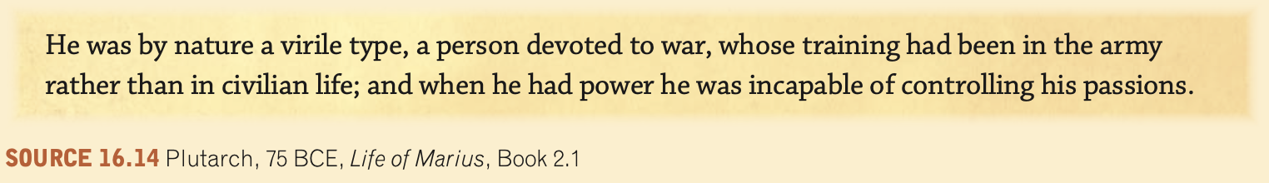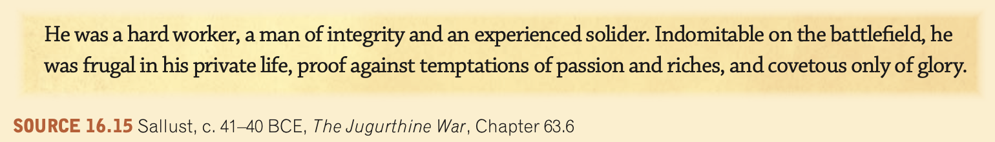

**Source 2**